SwitchVI Experiment 21 February 2007

SwitchVI = Switch Verbal or Implicit structure. Experiment in which color (third dimension) indicates assignment of category labels to the two areas of category structure.
Ran as SwitchVI (groups 1-6) and SwitchVIC4 (groups 7&8).

Goal: Find out how number of categories (2 or 4) influence difficulty of the task when the underlying category structure is either rule-based (CJ) or implicit (II).

Motivation: In RBII, we found almost no learning in RBII2 when one of the structures to be learned was II, although the same task was learned in RBII4 . Now we want to look at II II and see, if 2 category task is difficult to learn when using different systems (then II II 2 should not be too bad), or when II is anyhow involved (then II II 2 will be bad, while II II 4 should be ok).

Conditions

There were 8 groups.
1 CJ CJ 2 control (cj2ci) 4 II II 2 control (ii2ci)
2 CJ CJ 2 switch (cj2cr) 5 II II 2 switch (ii2cr)
3 CJ CJ 4 color relev (cj4cr) 6 II II 4 color relevant (ii4cr)

7 CJ CJ 4 control (cj4ci) 8 II II 4 control (ii4ci)

The design is sort of 2x2x2, but taken with caution. The three “factors” would then be (1) category structure (CJ or II), (2) number of categories (2 or 4), (3) color of ellipse relevant or irrelevant (cr/ci). I used this notation for naming the data files.
Originally designed as 2 category structures (CJ or II) x 3 conditions (2 cat control; 2 cat swich assignment between white and black; 4 cat – different label for white and black). The “control” 4 category condition (color irrelevant, 4 categories within each color) was added later.
You can get the best idea by looking at the stimulus structure plots:

II II 2 control (color irrelevant, black and white will be counterbalanced):
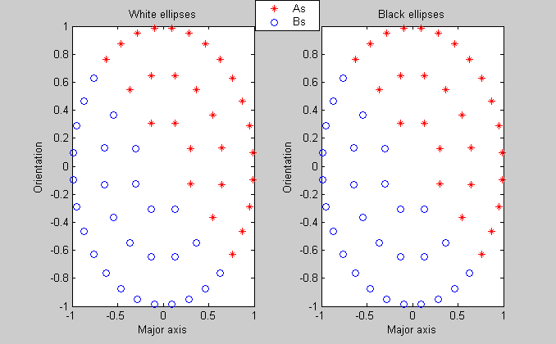
II II 2 switch assignments (color relevant)
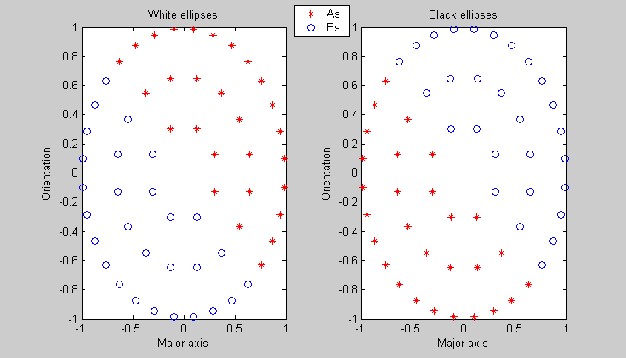
II II 4 color relevant:
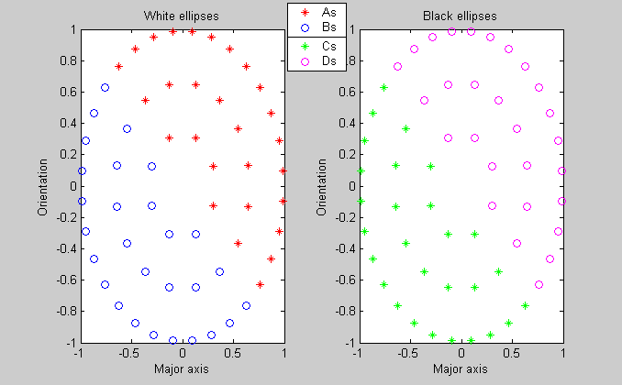
II II 4 control (color irrelevant)
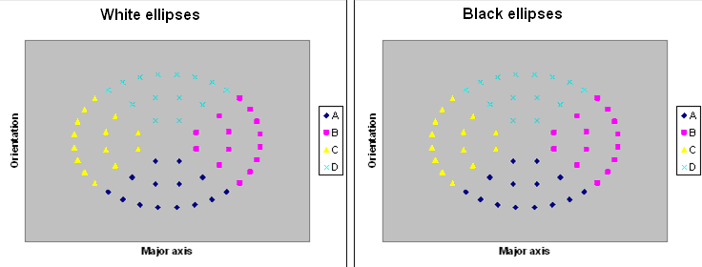

Some more info about RBII & SwitchVI category structure and stimuli

Category structure: Circular category structure including two dimensions. The circular structure consist of 56 stimuli total (28 for each category) organized in three layers. The first layer is a octagon, second 16-gon, and third 32-gon. The circular category structure was obtained by creating three concentric polygons within -1 to 1 scale.
Third dimension (binary) decides which category assignment the stimulus follows. There are 2*56=112 unique stimuli (see figure).

Stimuli: Ellipses that vary in major axis and orientation (dimensions determining category structure) and color (black or white determining category assignment).
The major axis is given by x-value and orientation of the main axis by y-value. Minor axis was kept of constant length. Color of the ellipse was given by third dimension. Value of zero is interpreted as black elipse while value of one as white elipse.
Minor axis was chosen to be 40 pixels.
Major axis varied between 1.5 and 2.5 times minor axis.
Orientation varied between pi/16 and 7pi/16.

Example of a stimulus.


Procedure

Trial design
CD type:
(resp terminated) cat stimulus
response
750ms feedback ('correct' in green, 'wrong' in red)
1500ms ITI
Experiment design:
There are 5 blocks of 112 stimuli, making 560 trials. During break, message “You have completed X out of 560 trials. Nice job. Press any key to continue.” appears.

Response keys are “C” “V” “B” and “N” in 4 cat condition and “Z” and “M” in 2 cat.
Bonus will be given for 60% accuracy in the first half and 70% accuracy in the second half of the experiment.

